COMPUTER SCIENCE

PROJECT FILE

KENDRIYA VIDYALAYA, SEC -5, DWARKA



SUBMITTED TO: - SUBMITTED BY: -

_________________ ____________

Mrs. CHANDRAKIRAN SATDEVE 12th A

(PGT COMPUTER SCIENCE) CBSE ROLL NO.: -

______________

INDEX

**S. No. Description Page No.**

Certificate 4

Acknowledgement 5

Introduction 6

Objectives 7

Hardware and Software Requirements 8

Entity Relationship(ER) Diagram 9

Flowchart 10

Modules used 11

SQL – Coding 12

Source Code 13

Modules 18

Output 26

Bibliography 32

CERTIFICATE

This is to certify that **Miss _________** of class XII-A, Roll no._ _ _ _ _ _ _ has completed her project work entitled “**BANK MANAGEMENT”**, as a part of COMPUTER SCIENCE under my supervision and guidance. To the best of my knowledge, it is an original piece of work once is worthy of consideration in practical fulfilment of the requirement of CBSE, Delhi for the award of senior school certificate in science for the session **2019 – 20.**

Signature of Internal Examiner:

Signature of External Examiner:

PRINCIPAL

ACKNOWLEDGEMENT

It is with great pleasure that I find myself penning down these lines to express my sincere thanks to various people who helped me a long way in completing this project.

My sincere thanks to our principal,

**Mr. Satish Kumar** who provided us harmonious climate in our school for preparing the project. It was a privilege to have been guided by

**Mrs. Chandrakiran Satdeve (PGT Computer Science).**

Thanks to all my classmates who helped me during the development of this project with their constructive criticism and advice.

INTRODUCTION

The project on ‘BANK MANAGEMENT’ describes the main activities that are performed in a bank but utmost care has been taken to make the system efficient and user friendly. With this system both the users namely customer and employee of a particular bank will find it easy to use and able to perform their operations. This project is made to maintain records and data of customers in a database by employees and provides facilities for customers to look up on their account situations. This computer-based management system is designed to handle all the primary information required.

OBJECTIVES

The main objective of this project is to provide flexible solution to the banking industry. The project on ‘BANK MANAGEMENT’ has been designed to computerize the following facilities:

1. Opening a new account

2. Closing the existing account

3. Transaction records

4. Fixed deposit

5. Loan sanction

The basic objective of this project is to simplify the day to day activities of a bank and to provide fast, efficient and reliable system.

HARDWARE REQUIREMENTS

* Windows 10
* 2 GB RAM
* Intel ® Atom™ x64-bit Processor

SOFTWARE REQUIREMENTS

* Python 3.8 32-bit
* MySQL 5.6.26

ENTITY RELATIONSHIP DIAGRAM

**IN**

**TAKEN FROM**

**FROM**

**IN**

FLOWCHART

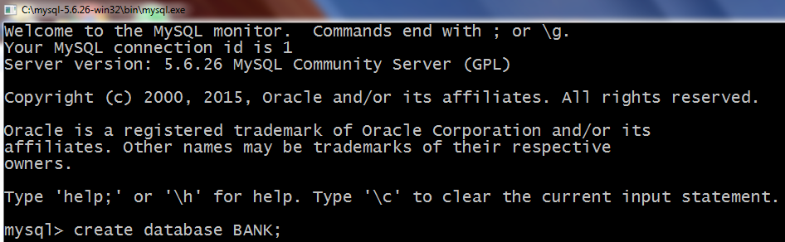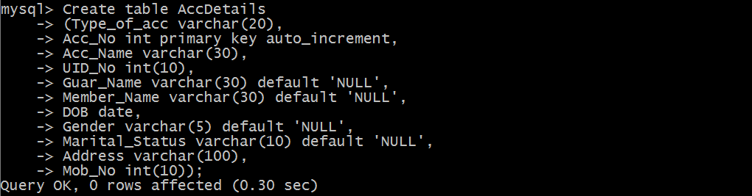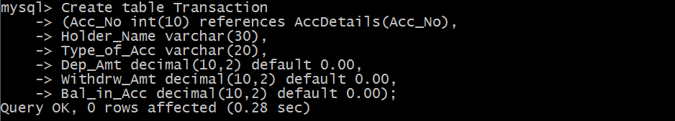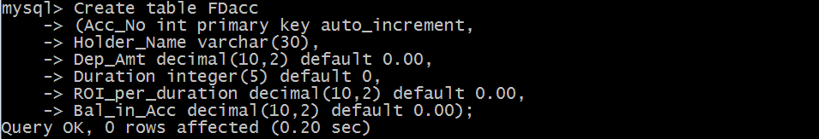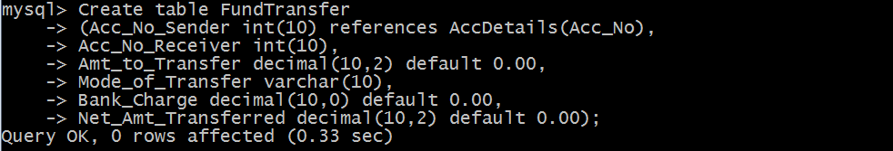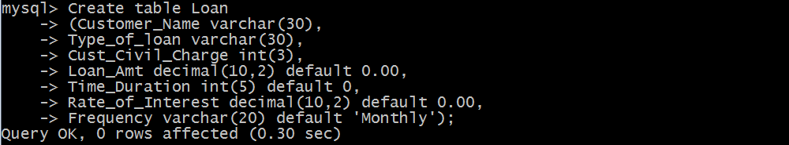SQL CODING

SOURCE CODE